**Step 2: Data Analysis & Insights (30 Marks)**

**Tools:** Power BI (DAX, Power Query), Python (Pandas, SQL)  
**Deliverable:** A 2-page report with key findings and calculations.

**User Behavior Insights:**

1. **Active Users:**

(In Power BI, use COUNTROWS(FILTER(Users, Users[Last Login] >= TODAY()-30))).

1. **Most Popular Treatments:**

(Power BI: Use **bar chart** with COUNT(Bookings[Booking ID]) by Treatment).

1. **Average Time Spent by User Category:**

In power BI we can find using a plot Average session min by User_type

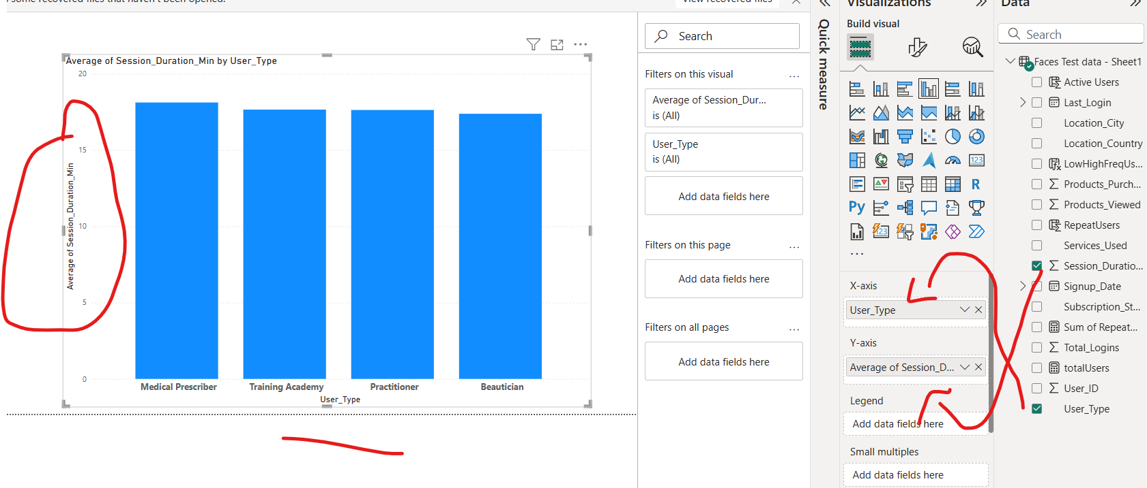

**Geographic Trends:**

1. **Top Regions:**

In power BI we can find using a plot i-e

* Count of User-id by Location_Country
* Count of service User by Location_Country

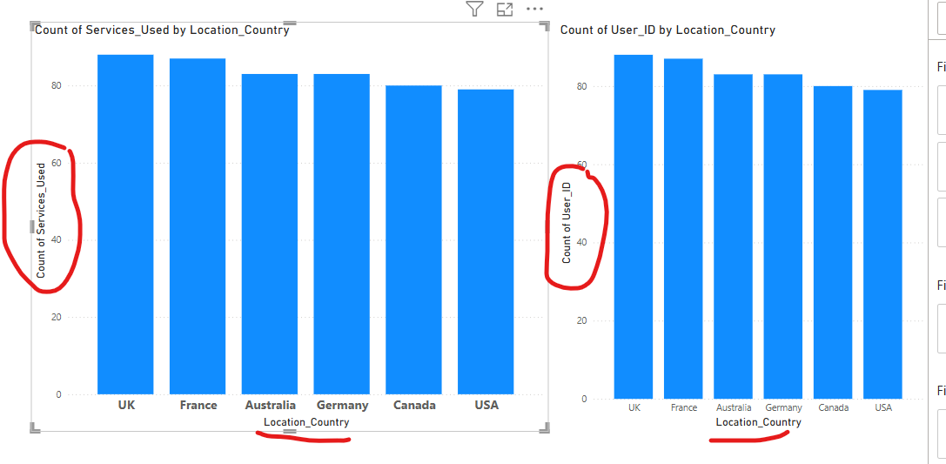

1. **User Location Breakdown (%):**

In power BI we can find using a plot “Grand Total count of User ID by Location_Country”

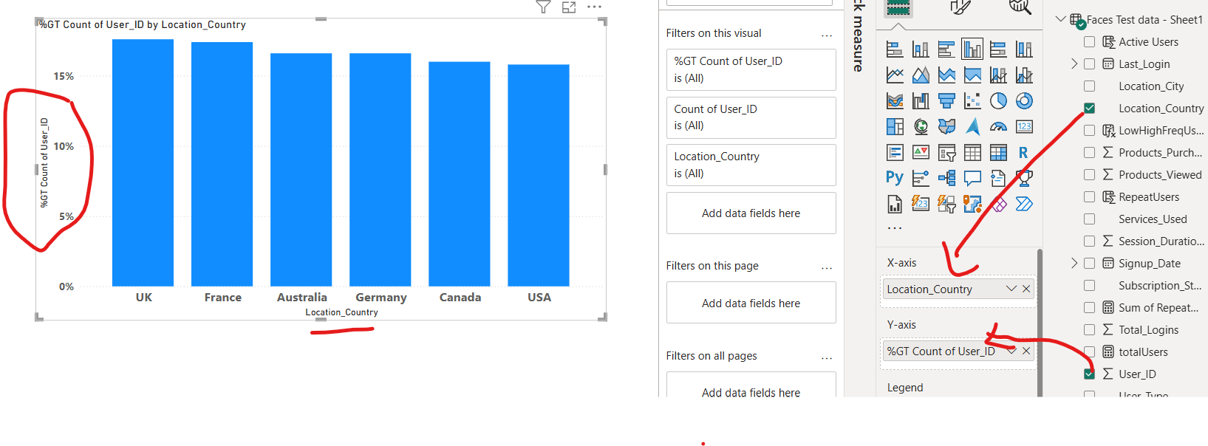

**Engagement & Retention:**

1. **Repeat Users (%):**

Answer: Create a column of repeated users and write formula “

RepeatUsers = CALCULATE(

    COUNT('Faces Test data - Sheet1'[User_ID]),

    'Faces Test data - Sheet1'[Total_Logins] > 3

)

1. **Drop-Off Rate:**

There are no drop-off rates where client has not avail any services